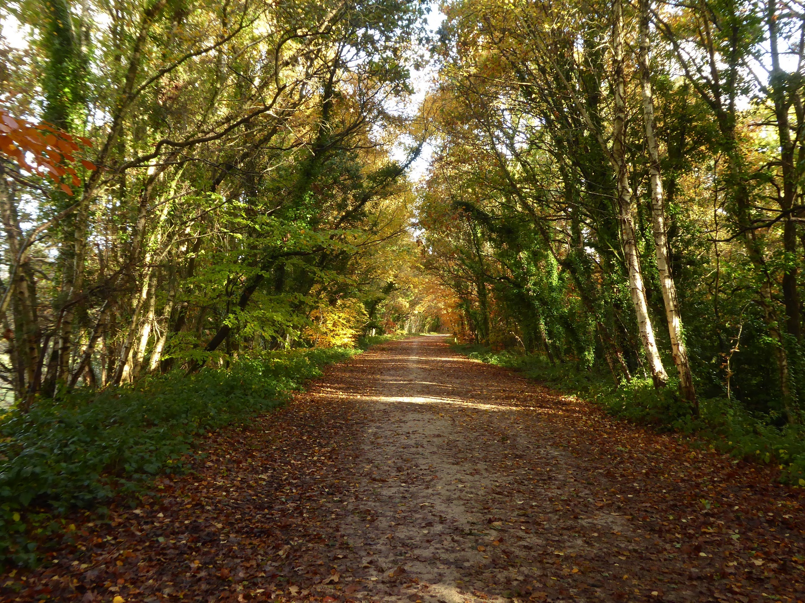

Broadstone Residents Survey

May 2021

Broadstone Neighbourhood Forum

Contents

Contents 1
Survey introduction 3
Survey overview 3
The survey 3
The respondent population gender, age range, employment status and health condition. 3
The parts of Broadstone where the respondents live 4
Areas of Broadstone broken down by age ranges 6
Areas of Broadstone broken down by gender 7
Areas of Broadstone broken down by status 8
Areas of Broadstone broken down by the method of transport used to get to Broadstone 9
Statistical Results 10
Q4. What do you think Broadstone (where you live, work or visit) would most benefit from having more of? 10
Q5. How would you rate Broadstone as a place to live? 10
Q6. Thinking about the future for Broadstone, are you concerned about any of the following? 11
Q7. Thinking about what makes places successful and what places do not work well – what do you think is most important to get right? 13
Q8. Which images do you think represent Broadstone in a positive way today? 14
Q14. Thinking about the whole Broadstone area, what priority would you give the following? NB/ not all of these are something that the Neighbourhood Plan can necessarily deliver. 15
Q15. For the majority of journeys within Broadstone, how do you get about? 16
Q16. Would you use the centre/Broadway more if .... 17
4. Narrative Results 18
Q9. Other areas in Broadstone that represent Broadstone in a positive way 18
Q10. What one thing would you say is best about being in Broadstone? 18
Q11. In addition to those areas that you said represent Broadstone in a positive way in Q9, what other places in Broadstone do you like? 18
Q12. What one thing would you most like to change about the centre/Broadway? 18
Q13. What one thing would you most like to change about the area where you live or are based? Please identify the area from the map in 18
Q17. Is there anything else you think is particularly missing from Broadstone's centre/Broadway? 18
Q18. Thinking about Broadstone in the past, is there anything you think we can learn from the past, to make Broadstone better? 18
Q19. Is there anything else you would like to say? 18
Summary 22

Survey introduction

Survey overview
In order that the Broadstone Neighbourhood Plan can be updated to reflect the views of the residents, the residents of Broadstone were asked to complete a short survey to help the Broadstone Neighbourhood Forum understand what needs to be considered when preparing the revisions of the Neighbourhood Plan going forward. The following is the result of that survey.

The survey
The survey was conducted using Survey Monkey. The survey closed on the 31st May 2021, the number of respondents was 241. The Broadstone ward is circa 10,000 people. So, with a sample size of 241 it can be concluded with a 95% confidence level and a 6% margin of error that the survey sample is representative of the wider population.
The following sections describe the demographic of the population that completed the survey.

The respondent population gender, age range, employment status and health condition.

The following chart shows a breakdown of the survey participants. The height of the bar in the chart is the total number of participants in that age group with the colour indicating gender.

Out of the 238 respondents 11% said that they had a long-term health condition, 83% did not and 6% preferred not to say.

The following chart shows the employment status of the respondents, most of which were either retired or employed/self-employed.

The parts of Broadstone where the respondents live

The following chart and map show where the survey participants live and shows a good overall spread over the Broadstone area. Out of all the participants 90% were residents, 1% Businesses and 7% were just shoppers.

Th following four charts show the Broadstone ward and boundaries. Each map includes pie charts for the individual parts of Broadstone. The size of the pie represents the population of respondents in that area and the pie segments show the proportion of those people for each criterion.

Areas of Broadstone broken down by age ranges

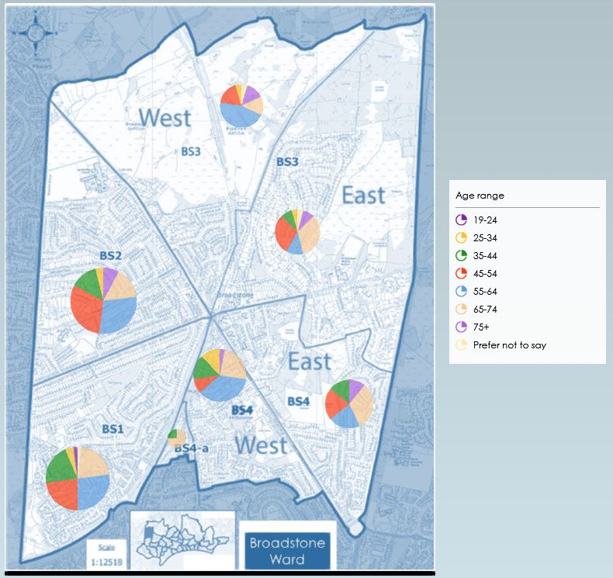

Areas of Broadstone broken down by gender

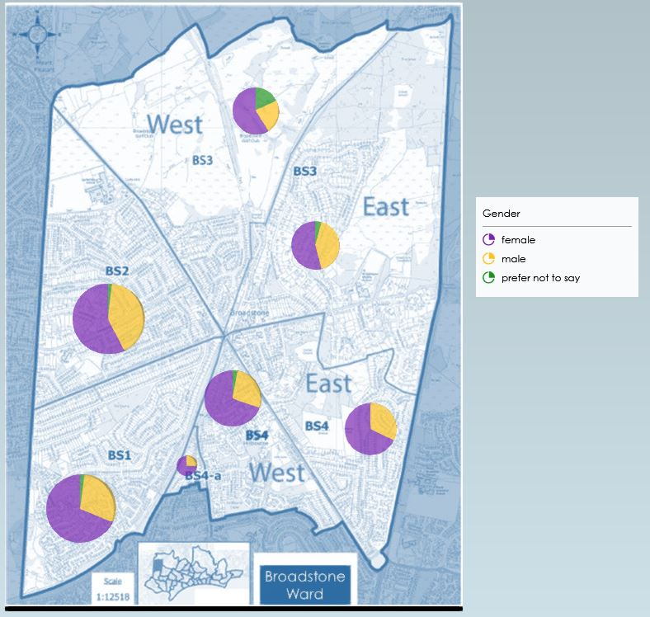

Areas of Broadstone broken down by status

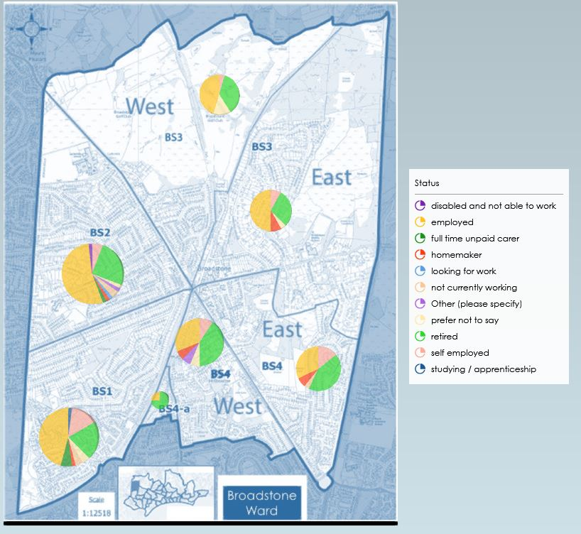

What is interesting in the above chart is the change in the number of status, going from north Broadstone to southeast. In BS3 there are only 4/5 status categories whereas in BS1 and BS2 all 11 categories are covered. This is probably due to the age profile which can be seen in a previous chart.

Areas of Broadstone broken down by the method of transport used to get to Broadstone

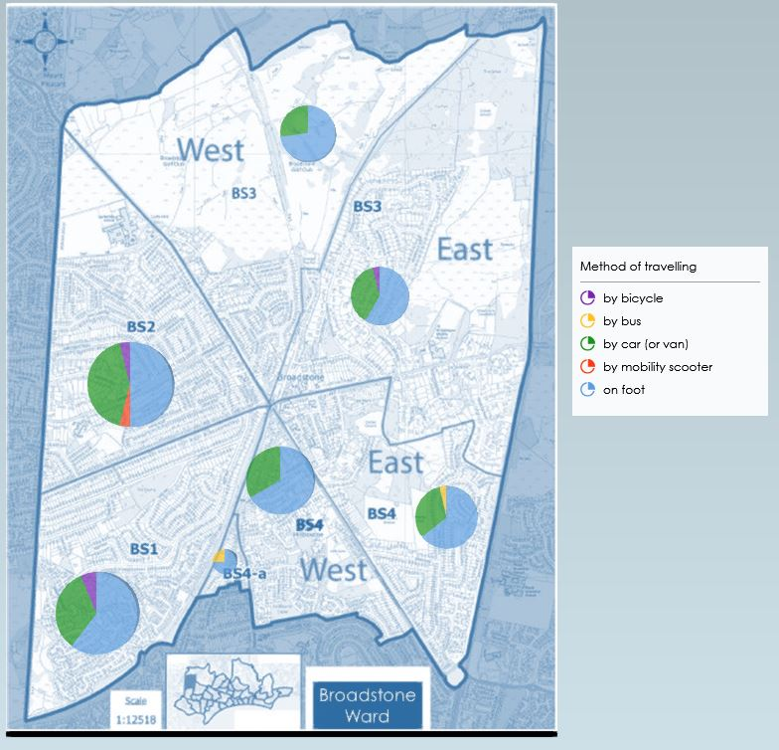
Even with cycle routes the numbers of people cycling into Broadstone is low, the majority traveling on foot or by car.

Statistical Results

The following section contains the charting and commentary for the questions that can be analysed in a statistical manner. In all cases the charts are showing the number of responses given to each question or sub element of a question where multiple responses were allowed.

Q4. What do you think Broadstone (where you live, work or visit) would most benefit from having more of?

Homes are the least important element for Broadstone residents, the 5 ‘home’ categories being at the bottom of the benefits to Broadstone. Social activities and green spaces hold the top positions, but parking and surprisingly business units rank high. Th interpretation of business units may be a pointer to more shops and commercial premises rather than “business units” as such

Q5. How would you rate Broadstone as a place to live?

The best observation that can be taken from this chart is that no-one thought Broadstone a poor place to live in fact the majority of people said Broadstone is either really great or good.

Q6. Thinking about the future for Broadstone, are you concerned about any of the following?
The following chart shows the surveys participants concerns for the future of Broadstone

Whilst at first sight this chart looks complex it does highlight three significant areas of concern, those being closure of shops, increased congestion and loss of green spaces.
To rank all the responses taking account levels of concern, a Net Promotor Score (NPS) technique has been used, which is basically the difference in percentages of Promoters and Detractors. The diagram below shows the ranking with green showing the highest ranked concern and red the least.
 | NPS
Potential loss of our green spaces and wildlife areas | 36%
The closure of local shops and services | 18%
Increased traffic congestion | 14%
Increased air pollution | -11%
Climate change | -14%
The lack of things to do for young people | -16%
The loss of historic buildings | -19%
Sustainability | -35%
Loss or reduction of bus services | -36%
The dangers of getting about on foot / cycle | -40%
The price of housing | -43%
The lack of job opportunities | -53%
Increased flood risk | -57%

Based on the demographic of the population described earlier it is not surprising that concerns over lack of job opportunities is low as is the risk of flooding. It is also pleasing to see climate change, air pollution as well as sustainability reasonably high up in the ranking. The sample population were also concerned about the lack of things for young people to do and the loss of historic buildings, of which there are many located in Broadstone.

Q7. Thinking about what makes places successful and what places do not work well – what do you think is most important to get right?

The green spaces rank high again for this question, but again parking is up there with the top rankings. Access to public transport, walking and cycle routes is an interesting one since earlier it was clear that the majority of people either drive or walk into Broadstone, this may have been too broad a question and difficult to interpret which of the three elements in the question is being responded to. It is disappointing to see sustainability and eco-credentials so low.

Q8. Which images do you think represent Broadstone in a positive way today?
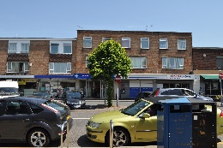
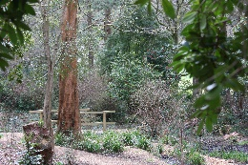
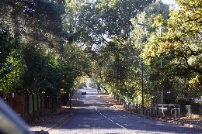
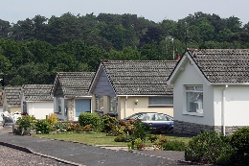
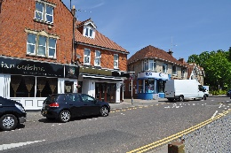
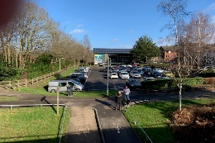
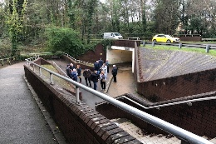
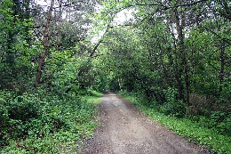
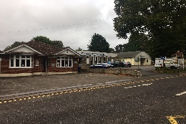

The top three ranked photos all include green spaces, it is becoming apparent from this question and previous ones that the residents of Broadstone want to retain or increase green spaces.

Q14. Thinking about the whole Broadstone area, what priority would you give the following? NB/ not all of these are something that the Neighbourhood Plan can necessarily deliver.

 | NPS
having a range of accessible green spaces, wildlife areas and tree cover | 60%
having local facilities such as library, community centre, community halls, youth centre | 36%
supporting the centre/Broadway to adapt to a changing economy | 16%
improving traffic flows by local road improvements | -18%
influencing the design of buildings to make them more ‘eco-friendly’ | -19%
having better pedestrian and cycle route links | -27%
improving local bus services | -28%
providing more car parking | -30%
influencing the design of buildings to make them more ‘beautiful’ | -38%
having a mix of housing that meets local needs | -49%
identifying more sites for different business uses | -66%
having a mix of employment sites that meets local needs | -71%
identifying more sites for affordable housing | -72%

The overwhelming priority is given to green spaces, wildlife and tree cover, with local community ad community facilities second on the list of priorities. Support for adapting the Broadway to suit the changing economy was the only other criteria to get a positive NPS score. The rest are all negative suggesting the detractors and people who really don’t consider them a priority well outnumber the respondents that considered them a high priority and gave them their vote.

Q15. For the majority of journeys within Broadstone, how do you get about?

What is interesting in this chart is the number of people who walk into Broadstone and so few cycle, especially since three of the main arteries into Broadstone, Dunyeats Road, Blandford Road and the Castleman Trailway all have cycle lanes. One likely reason for this is that people come into Broadstone to shop and carrying a lot of items on a bicycle may be seen as hazardous.

Q16. Would you use the centre/Broadway more if ....

 | NPS
There were different shops and services | 22%
There was more community activity on offer | -9%
The subway in the roundabout was more pleasant | -19%
There was more car parking available | -28%
The streets were pedestrianised | -30%
Improved pedestrian road crossings | -41%
There was a better bus service to and from the centre/Broadway | -52%
There was more cycle parking provided | -54%

In general people who responded were interested in the ‘content’ of Broadstone and not the transport infrastructure withy the top two activities being range of shops and community activity. Interesting again cycling, this time in terms of cycle racks was at the bottom along with public transport.

4. Narrative Results

The following section contains the results of the open questions that cannot be simply analysed in a statistical manner.

Q9. Other areas in Broadstone that represent Broadstone in a positive way

Q10. What one thing would you say is best about being in Broadstone?

Q11. In addition to those areas that you said represent Broadstone in a positive way in Q9, what other places in Broadstone do you like?

Q12. What one thing would you most like to change about the centre/Broadway?

Q13. What one thing would you most like to change about the area where you live or are based? Please identify the area from the map in

Q17. Is there anything else you think is particularly missing from Broadstone's centre/Broadway?

Q18. Thinking about Broadstone in the past, is there anything you think we can learn from the past, to make Broadstone better?

Q19. Is there anything else you would like to say?

What did people say to us about each of the above questions?

The above questions resulted in around 1400 comments. A fantastic level of response! We have read and considered our reaction to each one. All of them have been assessed in regard to an impact on our Neighbourhood Plan. What we have sought to do below is the bring together like responses under headings and set out, broadly, what the comments were saying.

Dunyeats Road

There were 21 comments on Dunyeats Road and in particular the shared pedestrian/cycle path. One respondent liked the path the other 20 commented on how dangerous it was – almost all using that word, that the junction views were limited and a few thought that it should be reverted to the previous guise.

Other people commented on the inappropriate positioning of the traffic lights and zebra crossing and the impact on safety.

Traffic and Traffic Management

There were 79 comments about traffic and traffic management. Most of the comments were about traffic volume and speed. A number supported the planned 20 m.p.h. speed restrictions and others wanted them on other roads.

Parking

93 comments talked about parking. Most comments wanted more parking or free parking or lower parking charges. Many commented about how bad parking was at peak times. A few comments wanted to see changes in the Toast Rack parking arrangements. Some talked about parking issues in their roads (including yellow lines) and on peoples’ driveways and on pavements.

Toast Rack

We had 80 comments about the Toast Rack. Most recognised the Toast Rack as a ‘challenge’. Some commented on the queuing and subsequent blocking of the Broadway. A number of people wanted to get rid of the Toast Rack but others didn’t. A number commented on the variety of problems that can occur. Some people, perhaps the majority, suggested using it for other things such as outside seating and/or pedestrianisation. Others wanted the spaces widened.

The Broadway

There were 65 comments that mentioned the Broadway. Many comments recognised how the Broadway gave Broadstone character and that it had a variety of shops and amenities. People saw it as accessible due to its transport links. Other comments mentioned making the environment more attractive with ideas such as planters, hanging baskets, trees and more seating opportunities or an area for community events. One person commented on the flooding near the roundabout.

Public Transport

There were 30 comments about public transport. People saw the importance of preserving or enhancing the bus services. One person wanted a direct service to Bournemouth. 12 people even wanted to bring back the trains!

Pedestrians and Cyclists

36 comments were about pedestrians and cyclists. The majority of comments about this suggested pedestrianisation of various parts of the Broadway. Other comments included widening pavements and providing more opportunities or facilities for cyclists, including making it safer for cyclists, and several identified the importance of providing secure cycle parking. Some were concerned about cyclists ‘whizzing around like battlebots’.

Shops and other establishments

There were over 170 comments about the shops and Broadway establishments. The majority valued, and saw the need to support, local businesses. People thought there was a good mix and variety of shops and other businesses and the convenience of those opportunities being available locally. There were a wide variety of comments/suggestions including:- More shop ‘types’ (motor accessories, electrical goods), no more charity shops and filling empty shops with independent retailers.

Natural Environment

Over 100 comments were about the natural environment in and around Broadstone. Everybody valued and wanted to retain the likes of Delph Woods, Broadstone Rec, The Heath, Springdale Park or Pocket Park – and other areas. People liked it that these areas were around Broadstone and others valued the chance to walk and enjoy these areas.

Location

20 comments recognised the advantage of the location of Broadstone in relation to Poole, the countryside, the Purbecks and the sea. Others simply saw Broadstone and a nice location.

Housing

Over 40 comments were about housing. Many wanted more homes with a ‘purpose’. For example, bungalows to enable residents to downsize or homes for younger families. People were keen to retain the quality of development and thought we should retain those buildings of character in Broadstone. There were also things people said they did not want to see such as ‘back garden’ development or flats.

Eating

27 comments talked about ‘hospitality’ opportunities. People wanted high end restaurants, cafes with outdoor seating and bars and other restaurants. People also wanted to have a café culture, outdoor space and places to eat out in the evening.

Facilities

There were well over 200 comments discussing the facilities and opportunities in Broadstone. There were a huge variety of things that people enjoyed and suggested. Those valued included good schools, the recreation ground, the trailway, the churches, the historic buildings (such as the Goods Yard), nice residential streets, the sports centre and the green spaces. Those facilities suggested included more doctors and dentists, reopening of the youth club, a jazz bar, a roller disco at the sports centre, musical events, outdoor space, local facilities to walk out, more play facilities and recreation locations to get to by foot.

Community

Well over 100 comments commented on the importance, and presence, of a community feel in Broadstone. People saw this being brought about by the schools, the churches, or the community spirit on the Broadway. Also, events such as the Christmas Parade and community facilities such as those already mentioned and the community centre, British Legion etc. People seemed to like the perceived ‘village’ feel and identity.

Behaviour

9 comments reflected on behaviour. Comments included one person who thought young people polite and 5 others who had a different view. People commented on vandalism, dog fouling and young people ‘hanging about’ on the Broadway or in the subway.

Miscellaneous

There were several other comments that were harder to attribute to a specific area. Many were ‘comedic’ including ideas such as the provision of stocks for punishment. Others included more regular cleaning of the underpass, less litter, bin collections, more bins/dog waste bins. A number commented on the poor standard of the road surfaces and pavements and potholes.

Summary
The results of the survey will be considered by the neighbourhood forum when developing the neighbourhood plan. The neighbourhood forum would like to thank all of those who took the time to take the survey.

